[F] PhD Extended Abstract Form [Please, to fill out use Calibri 10 typeface])

FULL PhD THESIS TITLE
DEVELOPMENT OF A PRECISION HEATING STRATEGY FOR SMART FROST MANAGEMENT IN APPLE ORCHARDS
by [Hua Weiyun; wvh5223@psu.edu; The Pennsylvania State University]
[The Pennsylvania State University; 436 Shortlidge Road, Agricultural Engineering Building, University Park, PA 16802]

Extended Abstract
[12000 characters max, spaces included. It is possible to include photographs, tables, and graphs]

1. INTRODUCTION
1.1 Background and research gaps
A vital and current global challenge is how to ensure adequate agricultural production with population increases worldwide. According to the report of the Food and Agriculture Organization, frost is a weather event that costs the most economic losses in the U.S. (Snyder and Melo-Abreu, 2005). Therefore, proper management operations for preventing frost damage on crops are important and necessary.
Heating is an effective method for frost protection and has been widely used to protect crops for growers. However, some research gaps still exist, and the critical challenges deter growers from taking active protection actions and simply relying on crop insurance. For example, the exact amount of heat energy required for frost protection in fields is difficult to know. In the field, insufficient heat input may lead to ineffective frost protection and excessive heat produced may lead to undesired energy waste in a particular spot. Therefore, it is important to develop a workflow to understand the heat transfer patterns and analyze the effects of various factors.
Frost protection performance can be improved by movable vehicle-based heating systems in orchards. Path planning is a key technology in utilizing autonomous vehicle systems and has been widely studied, but no study reported the utilization of multiple UGV-based heaters according to precision heating. Therefore, critical gaps still exist in the efficient path planning for multiple heaters in multiple cycles for frost protection. The challenges of the path planning algorithm in an orchard include dealing with collision avoidance among dynamic obstacles (heaters), avoiding static obstacles (tree rows), and reducing computational time because a multi-heater and multi-cycle algorithm is typically computationally expensive, which takes a long runtime for convergence, especially in a large orchard with tight tree rows. An optimal task assignment among multiple start locations and goal locations is thus needed in the path planning algorithm to reduce computational search time.
For preventing frost damage, one challenge is that most of the growers make heating decisions for frost protection based on their experience and approximation, leading to either insufficient heating or energy waste. The other challenge is that ambient wind is often treated as an uncontrollable factor when growers are implementing heating tasks in orchards, while it greatly affects heating performance. Therefore, it is necessary to monitor the environmental changes and take corresponding actions according to real time data.

1.2. Research Goal
The goal of the proposed research is to leverage advanced technologies aimed to enhance heating performance in orchard environments. In particular, heat transfer models, a multi-heater path planning algorithm, an estimation method of heater number, and a smart cyber-physical heating system for precision frost management were developed.

1.3. Objectives
The primary objectives associated with this goal statement are:
- Develop numerical models with gas heaters in an apple orchard to simulate temperature distributions and analyze the influences of the heater output intensity and velocity, heating angle, background wind direction and velocity, fixed heating, and mobile heating.
- Development of a precision heating-based path planning algorithm for multiple heaters and an estimation method to determine needed heater numbers according to various factors.
- Development of a smart cyber physical heating system to perceive the orchard environment and make corresponding heating decisions.

1.4. Overview of the Study
Fig. 1 provides a schematic of the overall research methodology and the following narrative describes the phases of the research.
Phase I: A three-dimensional numerical model was developed to simulate the fluid flow and heat transfer patterns in an orchard. The influences of heater output intensity, velocity, and heating angle on temperature distribution were investigated.
Phase II: A two-dimensional numerical model was developed to compare the heating performance of fixed heating and mobile heating. Various fixed heating layouts were designed and simulated. The effects of wind direction and velocity were also discussed.
Phase III: A precision heating strategy in which canopies with high heating demands had priority to be heated was proposed. A collision-free path planning algorithm based on precision heating was developed for multiple dynamic heaters in multiple heating cycles with the shortest path costs. Additionally, an estimation method for the heater number needed was presented based on orchard size, heater performance, and frost severity.
Phase IV: A smart cyber-physical heating system was designed based on a wind direction sensor, temperature sensors, and a rotatable and movable heater. The protection performance of the system was evaluated. The two field tests were conducted in low-temperature condition and additional field test was conducted in windy condition.
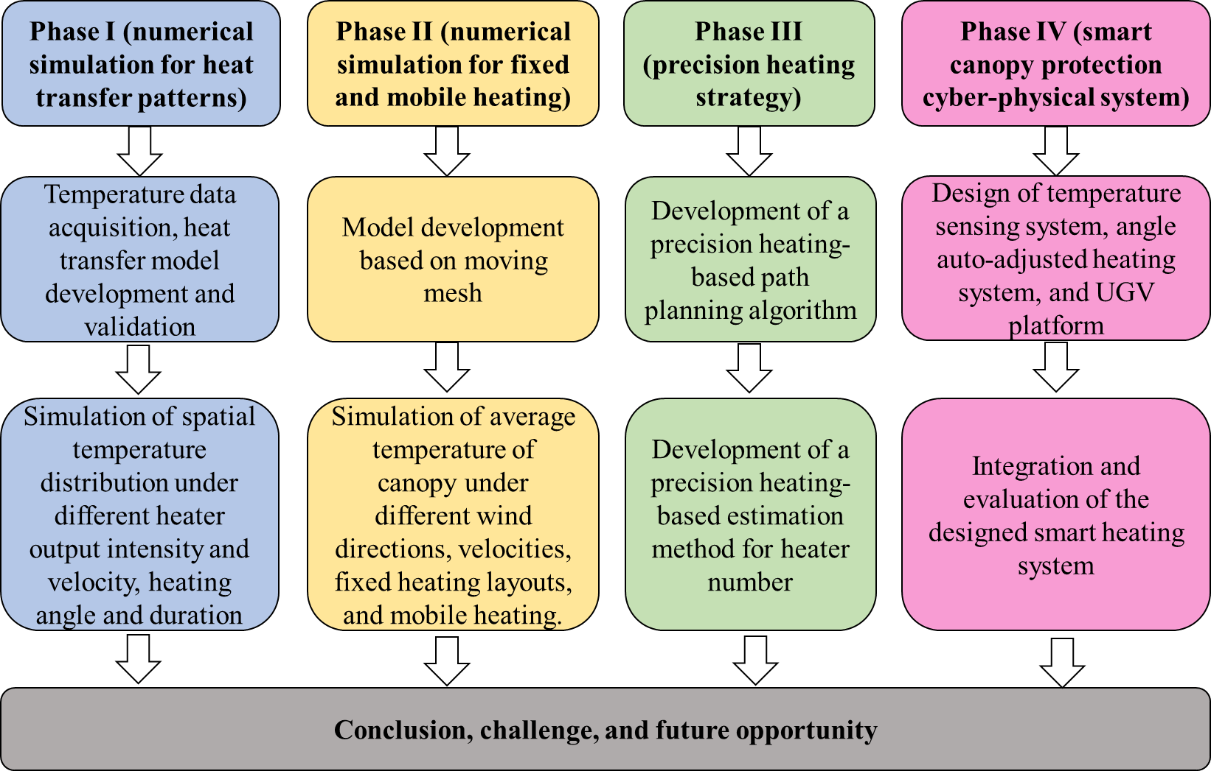
Figure 1. A general overview of the research methodology

2. CFD SIMULATION OF POROUS CANOPY HEAT TRANSFER IN APPLE ORCHARD-BASED FROST PROTECTION
Abstract
Frost is one of the severe weather events causing economic losses in agriculture. Much effort has been made to reduce frost damage to crops, and heating is among them. Traditional heating strategies can be insufficient or wasteful due to the lack of spatial temperature information thus not achieving adequate protection from frost or causing uneven heating problems. Computational fluid dynamics (CFD) modeling has been widely used to simulate fluid flow, heat, and mass transfer by predicting various processes such as spatial flow velocity, pressure, and temperature distribution within a simulated environment. A three-dimensional CFD model for simulating airflow and heat transfer in an apple orchard was developed and validated, with the effects of heater output intensity, output velocity, and heating angle analyzed. The validated model effectively predicted the spatial temperature changes over time inside the canopy for three representative heating schemes (heaters angled at 0°, 45°, and 90° toward a tree row) with an average root mean square error (RMSE) of 2.6 °C. The simulated results show that the heating scheme of heaters angled at 45° was the most effective, resulting in the largest average percentage of the protected canopy (72.3%), compared with heaters angled at 0° (33.1%) and 90° (56.5%). The average percentage of the protected canopy increased by 108.2% when the heater output intensity increased to 477,000 KJ·h⁻¹ and 46.0% when the heater output velocity increased to 15 m·s-1. However, the percentage of the protected canopy showed diminishing returns as the heater output intensity and velocity increased. The outcome of the study can be beneficial for making effective frost protection decisions in apple orchards.
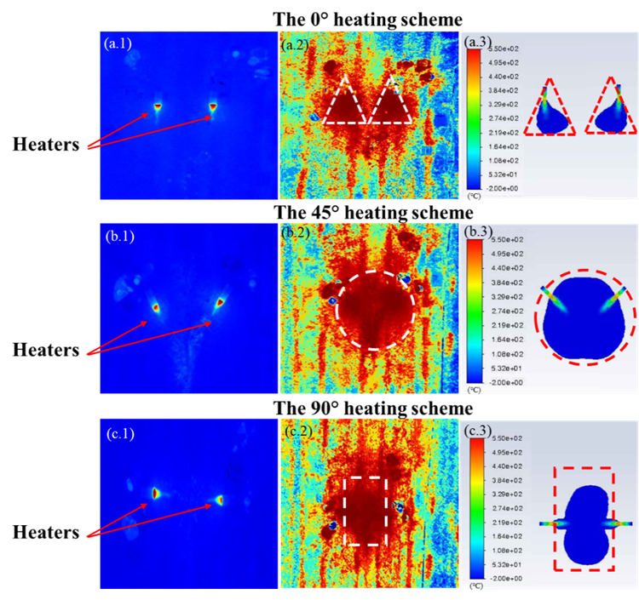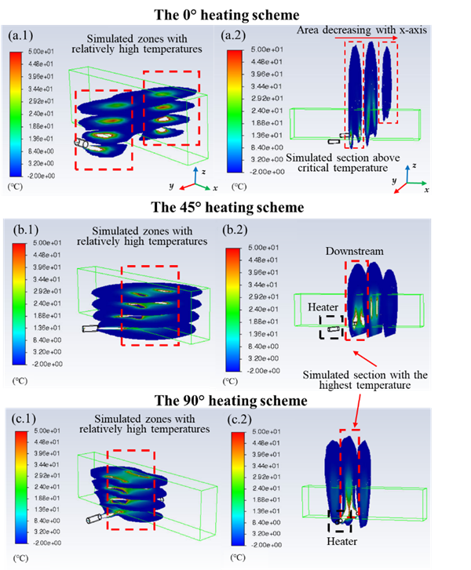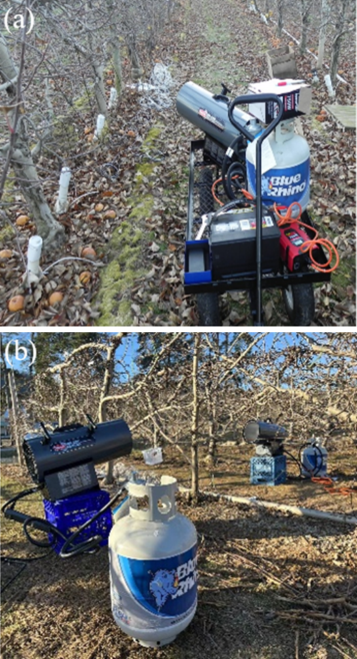
Figure 2. Thermal images and simulated temperature results from top view (left), 3D simulated temperature profiles (middle), and field tests (right).

3. HEAT TRANSFER MODELING WITH FIXED AND MOBILE HEATERS FOR FROST PROTECTION IN APPLE ORCHARDS
Abstract
Effective heating is important for protection of commercial crops from frost. In this chapter, a two-dimensional computational fluid dynamics (CFD) orchard model was developed to predict velocity and temperature distributions in an apple orchard from two forced air heaters. The effects of ambient wind direction and velocity were analyzed, suggesting that placing heaters angled upwind increased the average canopy temperature (ACT) but the ACT decreased as the ambient wind velocity increased. The simulated results also show that reducing the interaction of heat flows between heaters improved the ACT and the percentage of protected canopy (PPC) in the fixed heating layouts. However, the proposed fixed heating layouts provided insufficient protection performance of the canopy with only a maximum PPC of 32.1%. A mobile heating case i.e., moving the heaters from one end of the tree row to the other, was modeled based on a moving mesh simulation. Quantitative comparisons between the mobile heating case and three fixed heating cases, i.e., placing the heaters angled 45° at the end of tree row, the middle of the tree row, and the other end of the tree row, suggest that compared to the fixed heating cases, the simulated PPC for the mobile heating case increased by 457.8%, 251.9%, and 288.1% respectively.
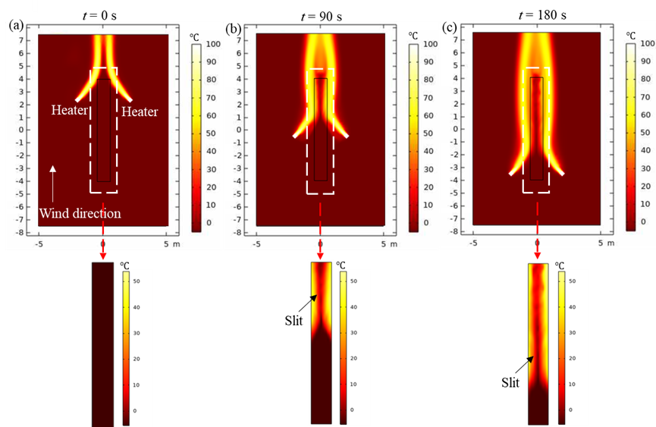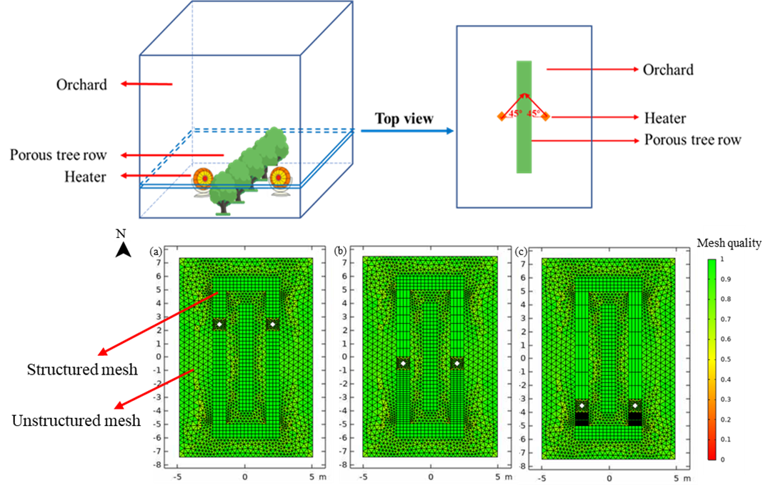

Figure 3. Simulated temperature profiles for mobile heating (left) and illustration of canopy model and deformed meshes for mobile heating (right)

4. PRECISION HEATING STRATEGY BASED DYNAMIC HEATER PATH PLANNING FOR FROST PROTECTION IN APPLE ORCHARDS
Abstract:
Frost is one of the severe weather events causing economic losses in agriculture. Traditional heating can be divided into fixed heating and mobile heating. The former is to use heaters at fixed locations during frost events in an orchard, and the latter is to use mobile heaters to travel through the whole orchard with a constant velocity. However, both traditional heating strategies have limited heating capacity. In this chapter, a precision heating strategy was proposed to prioritize applying heat to canopies with high heating demands in orchards by multiple heaters. The precision heating experiment in a simulated orchard environment with dynamic multiple goal points was implemented by an improved A-Star path-planning algorithm, in which a path cost estimation-based linear optimization method was presented to find the optimal paths for multiple heaters and a conflict-based search (CBS) method was used to generate collision-free paths. In addition, an estimation method for the heater number based on the precision heating strategy was proposed and the difference of the heater number between precision heating and traditional heating was compared. The simulated results show that the improved A-star algorithm had higher search efficiency, resulting in 36.8% and 98.7% less total path cost and computational time than the traditional A-Star algorithm. The comparison between precision heating and traditional heating indicates that the number of heaters used in the precision heating strategy decreased by 96.8% and 85.9% compared to the traditional fixed heating strategy and mobile heating strategy, respectively. Overall, this study provided a concept of high-demand priority precision heating and proved its superiority for frost protection.
Figure 4. Illustration of optimal paths for multiple heaters in the different simulated cycles.

5. CANOPY PROTECTION CYBER-PHYSICAL SYSTEM (CPCPS) FOR SMART AGRICULTURAL MANAGEMENT OF FROST DAMAGE IN APPLE ORCHARDS
Abstract
Frost events have resulted in huge economic losses in agriculture. Apple flower buds are susceptible to being damaged by cold weather in early spring, leading to reduced apple production. Applying heat is one of the most effective methods to prevent apple flower bud damage. However, growers generally determine when and how to apply heat in orchards based on their experiences and available labor force, leading to either insufficient heating or energy waste. In this chapter, a frost protection cyber-physical system (CPCPS) was developed to make heating decisions based on real-time ambient temperature and wind direction data. The CPCPS consisted of a real-time temperature sensing system, an angle auto-adjusted heater, and an unmanned ground vehicle (UGV) to move the heating system. The results show that the CPCPS improved protection performance during the field tests. Compared to the non-CPCPS, the CPCPS increased the percentages of canopy protected time by 198.8% and 111.9% in two low-temperature field tests. The outcome of the study can be beneficial for enhancing protection performance of canopies in apple orchards.
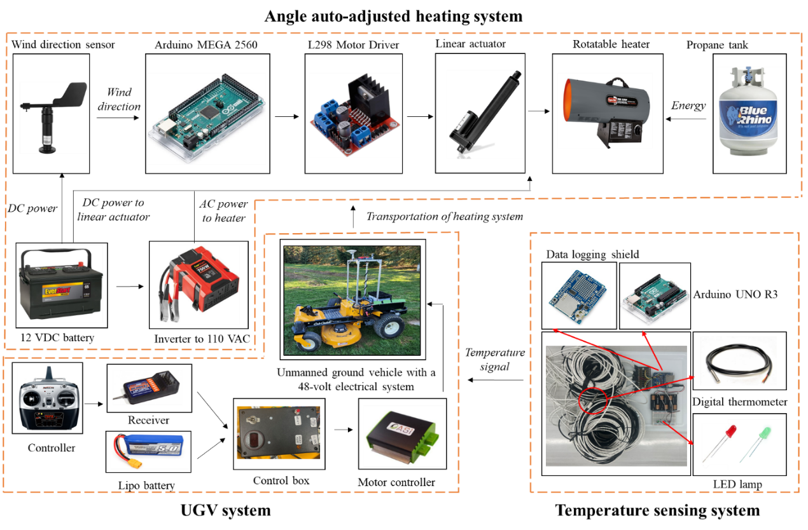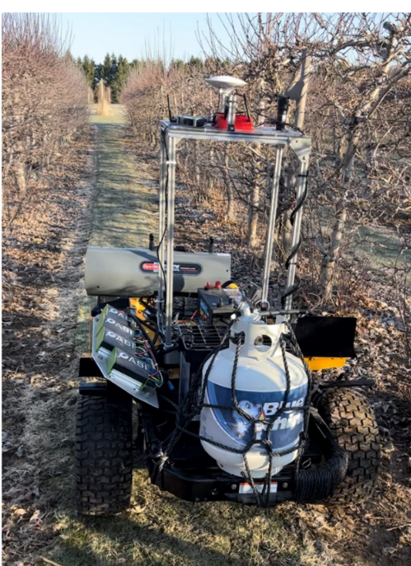
Figure 5. Illustration of the proposed heating system (left) and field tests (right).

Final remarks concerning benchmarks and strength points of the the Pellizzi Prize 2026
[compulsory chapter to fill with 1000 characters max, spaces included]
The research establishes a robust foundation for automated climate resilience in prescision agriculture. By integrating Cyber-Physical Systems (CPS) and Machine Learning, traditional frost management can be transitioned from reactive intervention to a proactive, data-driven science.
The core strength of this work lies in its precision heating strategy, which successfully balances the tension between energy conservation and crop protection.This study does more than automate hardware, thereby reducing labor cost during frost evets; meanwhile, it optimizes thermal delivery based on real-time field data, significantly reducing energy waste while ensuring crop security. The study has already moved from the lab into successful field tests, proving its potential for commercial-scale implementation. By bridging the gap between electronics, modeling, and hardware, this study provide valueable insights for solving fundamental frost challenges in agriculture.

ATTENTION PLEASE: save the filled file with the name: “FormF_ApplicantSURNAME.pdf”

